Project Design Phase-I Solution Architecture

|  |  |
| --- | --- |
| Date | 05 October 2022 |
| Team ID | IBM-Project-18403-1659684750 |
| Project Name | **Deep Learning Fundus Image Analysis for Early**  **Detection of Diabetic Retinopathy.** |
| Maximum  Marks | 2 Marks |

**AIM :**

To draw the Solution Architecture ***“MINIMUM VIABLE ARCHITECTURE”*** and To enlist the ***“TECHNOLOGIES NEEDED”*** for it.

MINIMUM VIABLE ARCHITECTURE :

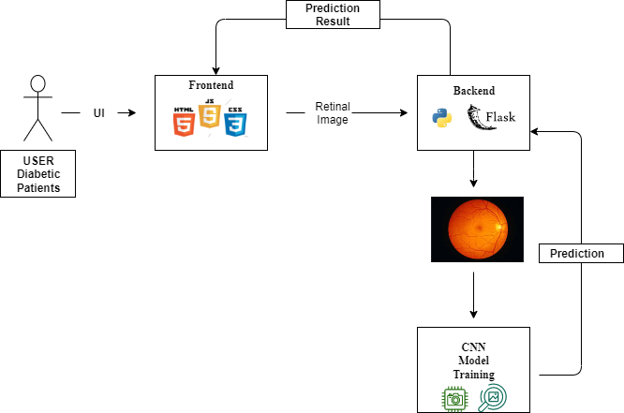

Technologies needed for Minimum Viable Product Development:

For the development and deployment of the project the following software technologies are required.

Front End:

* HTML
* CSS
* JavaScript
* Bootstrap

Back End:

* Python
* TensorFlow
* Image processing**(CNN)**
* Flask

Project Management :

* + GitRepo & GitHub

Hosting & Training :

*IBM CLOUD -* For Hosting the DataSet.

*IBM WATSON -* To Train the DL Model.